Volatility: stock's annualised log return volatility over remaining life of option (estimated)
A) 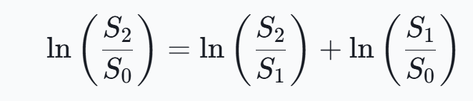 B) 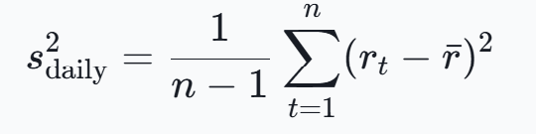

Historical/realised Volatility: (physical measure)
- Select lookback window (e.g 60 training days for 30 day option)
- Calc average return (daily)
- Calc daily historical volatility (B)
- Annualise (*sqrt(days))
Strengths:
- Simple/transparent/need only historical prices
Weaknesses:
- Backward-looking, arbitrary time window, need to weight days (EWMA), assumes same market conditions

Implied Volatility: (risk neutral measure ---> vol > other 2 as insurance against market crashes = variance risk premium)
Market prices contract as if vol is IV under BS
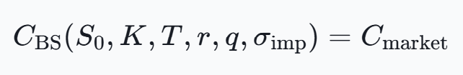 ---> solve for IV
- Plotting IV vs K for fixed T = vol smile/skew (low K for equity puts often more IV than at-money options – reflects downside protection demand due to sharp down move scares)
- 1 IV can’t price whole option chain

VIX: Annualised model-free measure of market's expected variance of S&P 500 index over next 30 days from S&P 500 index options (20 vol points = 20%) (built from set of near-term out-of-money SPX calls + puts over many strikes) (uses 2 option expiries surrounding 30 days + interpolates between for 30 day measure) (uses OTM puts below forward index level, OTM calls above forward index level, the average of call/put prices at strike nearest forward level)
- OTM puts more liquid as downside hedging and calls for upside speculation/heding = informative about tail-risk pricing, ITM has intrinsic value + time value so isolate time better with OTM
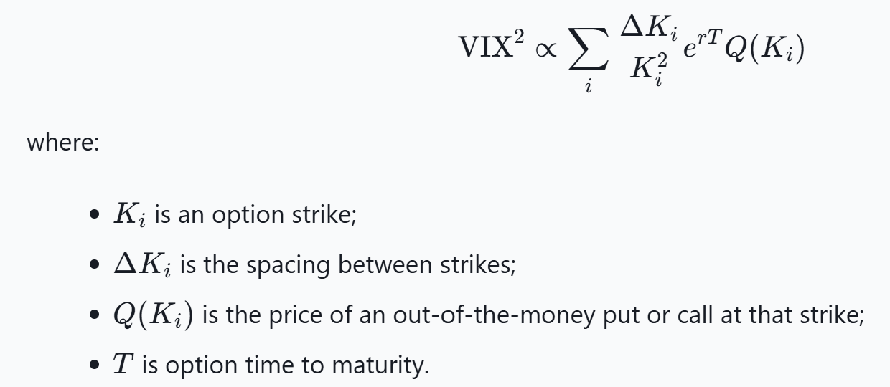

Strengths:
- Relevant benchmark for 30 day ish at-money SPX option + capture index level uncertainty
Weaknesses: (why not same as option's individual IV)
- Aggregates many strikes, represents 30 days + option can have diff expiry, option may be far from at-money, doesn’t take into account company specific risks for individual options
- Therefor stock IV can be high above VIX

GARCH: (physical measure)
Statistical approach: take into account vol clustering + mean reversion

Garch (1, 1) model: 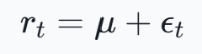 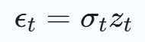 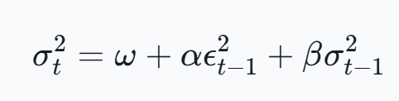
- ω = long-run +ve baseline – prevents variance collapsing to 0
- aϵ^2 = yesterdays surprise return (+/- move same effect)
- bσ^2 = persistence, if vol high yesterday, remains high (clustering)
- GARCH (1 = lagged squared return shock, 1 = lagged conditional variance)

If: 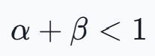 - model has finite long-run variance: 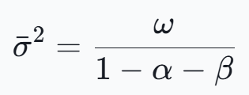 - shocks fade slowly (common in markets)
- Get long history of adjusted prices (so dont fake shocks)
- Calc daily log returns (low noise, more observations, add over time)
- Fit μ,ω,α,β (max likelihood + assume Zt shocks = normal/student’s t distribution (fat tails))
- Use most recent estimated conditional variance + return residual for variance forecasting (path of expected daily vars over all 30 days + average)
- Convert forcast (av.) to annualised vol for BS
- BS needs vol over remaining maturity so if H days left, cum variance:

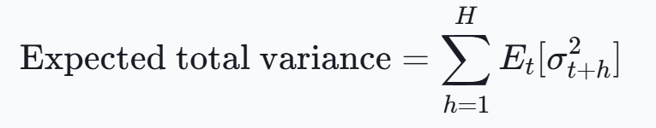 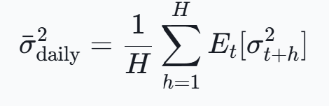 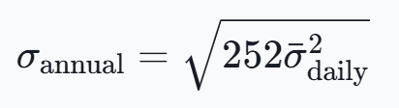 ----> use in BS
Weaknesses:
- +/- ve shocks treated equal but equity markets have leverage effect )-ve increase vol more) ---> use GJR-GARCH (add -ve shock term) or EGARCH (models log var + captures asymetric effects)

